**Project Design Phase-II**

**Data Flow Diagram & User Stories**

|  |  |
| --- | --- |
| Date | 03 October 2022 |
| Team ID | PNT2022TMID35612  **Explore AS, differentiate**  **Deﬁne CS, ﬁt into CC** |
| Project Name | Early Detection of Chronic Kidney Disease using Machine Learning |
| Maximum Marks | 4 Marks |

**Data Flow Diagrams:**

A Data Flow Diagram (DFD) is a traditional visual representation of the information flows within a system. A neat and clear DFD can depict the right amount of the system requirement graphically. It shows how data enters and leaves the system, what changes the information, and where data is stored.

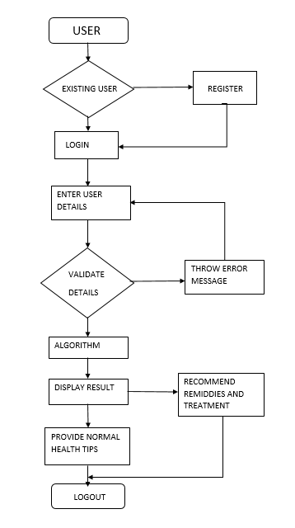

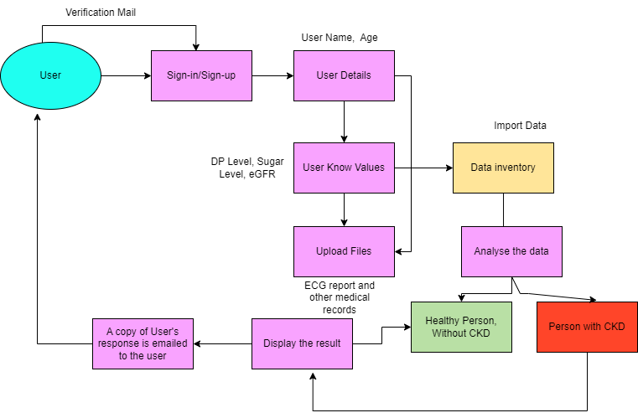

**User Stories**

Use the below template to list all the user stories for the product.

|  |  |  |  |  |  |  |
| --- | --- | --- | --- | --- | --- | --- |
| **User Type** | **Functional**  **Requirement (Epic)** | **User Story Number** | **User Story / Task** | **Acceptance criteria** | **Priority** | **Release** |
| Customer (web user) | Home page | USN 1 | As a user, I can see the home page of the application | I can access the home page of the application | Medium | Sprint-1 |
|  | Dashboard | USN 2 | As a user, I must enter the required  parameters required to make the prediction using ML model | I can view negative/  positive results produced after diagnosis | High | Sprint-2 |
|  | Result | USN 3 | As a user, I can view the report generated by the application (Prediction result – Positive/Negative) | I can view negative/ positive results produced after diagnosis | High | Sprint-3 |
| Administrator |  | USN 5 | As an administrator, I should identify the most significant factors that lead to CKD based on the present trend and come up with the input parameter that should be given by the user for  CKD prediction | I must identify input parameters required for CKD prediction | High | Sprint-2 |
|  | Prediction | USN 6 | As an administrator, I must use the most suitable ML model for detection of CKD | I should efficiently train the ML model | High | Sprint-3 |
|  |  | USN 7 | As an administrator, I must ensure that the application is live and is accessible on any device with internet connectivity (Deploying on  IBM cloud) | I should deploy the model on cloud | High | Sprint-4 |